Table of Contents

I. Project Overview.....................................................................................Page 2

---A brief look at what this project is about

II. Current Status..........................................................................................Page 3

---Rule updates and our schedule proximity

III. Completed Work.....................................................................................Page 4

---What we have accomplished

IV. Current Work..........................................................................................Page 6

---What we are doing now

V. Future Work............................................................................................Page 7

---What we plan to do next

VI. Summary and Conclusion......................... .............................................Page 8

---A quick recap of everything mentioned.

VII. Appendix A...........................................................................................Page10

---Schedules

VIII. Appendix B...........................................................................................Page13

---Design Sketches

I. Project Overview
Our project is the design and implementation of a Robot that will compete in the 2008 IEEE Region 5 Student Robotics Contest held in Kansas City, MO. The theme of this year’s contest is Hazardous Materials (HAZMAT) handling and storage. To compete in the contest the robot must be able to move, manipulate, and store containers according to their weight. These containers simulate “casks” which are similar to how an actual HAZMAT container would be in a warehouse environment. A cask will arrive at one end of the “warehouse” and be automatically retrieved, weighed, and stored in a bin designated for a certain weight classification without any human intervention. The use of robotic manipulation is needed in this application because handling HAZMAT is harmful to human beings.
The building of this robot will require a partnership between members of the ECE and CS departments. As the ECE portion of the team, we are primarily responsible for the design and construction of the mechanical body and all of the electronic interfacing necessary. We will also be accountable for the lower level programming to be implemented by a PSoC. Our current design consists of a chassis with omnidirectionability due to its wheel type and arrangement. A forklift will then be constructed and placed on a turnstile so it can rotate around the robot for pickup and delivery without the robot having to rotate itself. Weighing of the casks will be performed with the use of strain gauges arranged in a Wheatstone bridge. The movement of the robot will be monitored by optical encoders placed on each motor shaft. These will control a proportional, integral, derivative (PID) loop to ensure proper speed and direction. The motors, encoders, and strain gauges will be powered and controlled by the PSoC. An array of light sensors will also be constructed such that the robot will follow black lines on the track to get from one point to another.
II. Current Status
There have been a few changes in design from our initial proposal. The double forklift concept has been discarded primarily because a new set of contest rules has been produced and made accessible. The point of the double lift was for comparison purposes—if two of the casks were picked up and weighed, it could be decided which was the light, medium, and heavy by comparing the weights of the two collected. This would also reduce that amount of times the robot would have to travel from one end of the warehouse to the other. However, the new set of rules has established definite cask masses of 63, 126, and 189 grams. Also, accuracy of weight is not an objective. This means that we can be a little more lenient on our digital weight scale design. A weight value that is accurate to a few grams should be more than sufficient to complete the tasks for this competition. Two forks would also have required more mechanics and twice the sensory.
The precedence of our designs has also been altered. Instead of focusing on the lift, our priority has been to get a moveable frame such that the PID loop can be initiated and the line following code can be tested using lower level commands coming from the PSoC microcontroller. TABLE 7.1 shows the preliminary schedule while TABLE 7.2 shows a revised schedule including task division; both can be found in APPENDIX A. The final table of APPENDIX A, TABLE 7.3, shows the completed tasks from the schedule. As can be seen, some things are well ahead of the schedule. Many other items still need to be completed though. This table can be compared to the current overall design represented in as a block diagram in FIGURE 8.1 of APPENDIX B. The most current version of the competition rules can be found at http://ewh.ieee.org/conf/basics2/comp_robotics.php.
Another major change in our design is the wheel arrangement and the control of each wheel. An initial design idea involved using a set of relays capable of switching from one set of wheels to another but this poses another set of problems. The pulse width modulated signals being applied to the motors may be distorted causing problems to the differential control loops being implemented. Secondly, we cannot control all four wheels at once for proper turning operation.
We have recently learned that it is possible to use two microcontrollers separately. Since this type of design will undoubtedly work the best, we will be implementing it for our 4 wheel design. One PSoC will be devoted purely to wheel control, and the other will be devoted to the LCD display and the weight-scale as well as powering the lift and turnstile motors. This clears up any worries we had over available port space.
The only real problem we have had is trying to understand what last year’s team did and why they did it. There is not much documentation of how they did things, so to build off of their mistakes and accomplishments, more contact with them will need to be established. We do have copies of their source code for the XBC and the code used for the PSoC to control their motors and PID loop. This will be used as much as possible for simplicity.
III. Completed Work
Thus far, the PSoC microcontroller and the XBC platform are not as far along as the robot body. So far we have acquired the PSoC microcontroller itself and the software that comes with it. This software is needed to create digital components in the PSoC as well as to write and build the C code for the low level robot control. We also have a primitive version of the digital weight scale provided by Dr. Engel. This program displays a number directly from the strain gauges to the LCD module. This was done by taking samples from the analog input signal, amplifying them with an instrumentation amplifier and then converting them to a digital value.
Other work performed was on research and collaboration with Dr. Engel on how to use the PSoC since no one on our team has had any previous experience with using this type of microcontroller. The first step in creating the wheel control code is to study the code from last year’s robot since we will be building off of that. This has been started but has not been finished. We hope to have a robot that has basic movement control with the PSoC soon.
At this time, the robot chassis has been completed. An arrangement of 4” double transwheels was used for omnidirectionability—the robot can move in any direction at any time depending upon the speed of each wheel. Each wheel is individually powered using a 175 RPM gear head motor with a 50:1 internal gear ratio. A frame has been constructed out of aluminum to support the wheels and motors as well as the body of the robot. This chassis has taken the shape of a pound sign, #, with a metal bumper wrapping around the entire chassis to protect the wheels from obstacles. A sketch detailing the planned dimensions of the chassis frame can be found in APPENDIX B as FIGURE 8.2. FIGURE 3.2 shows the chassis with motors mounted while FIGURE 3.2 shows the completed frame with wheels.
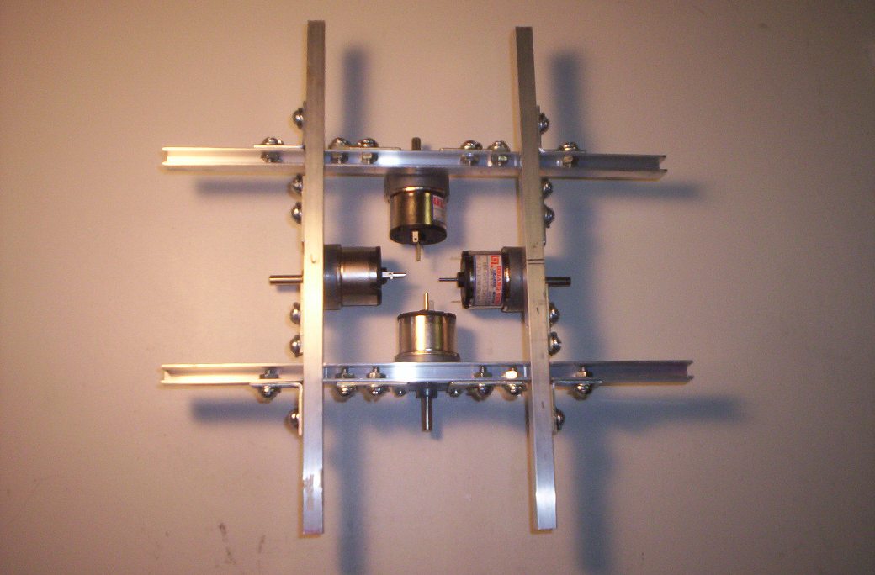  FIGURE 3.2 | 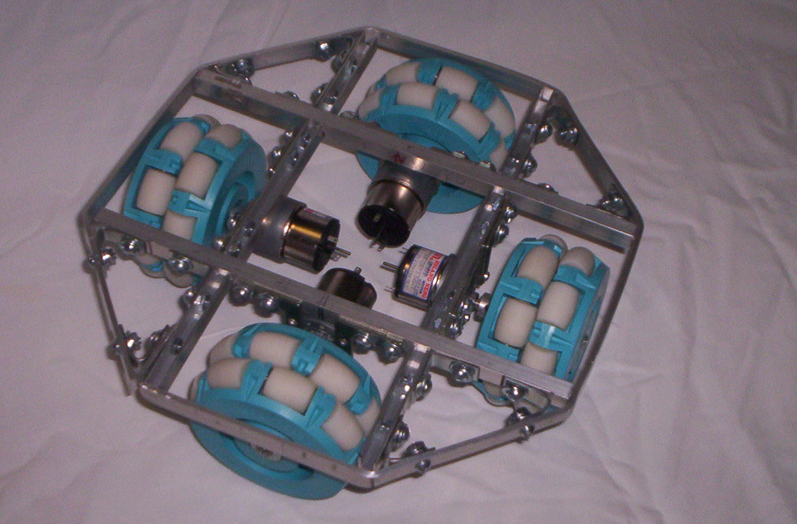  FIGURE 3.3

This chassis has been tested by applying the 7.2 V battery packs across two of the motors in parallel. Doing such caused the robot to drive in a straight line or turn in a circle, depending upon which battery leads was connected to which motor leads. Encoders have also been added to each motor to control a PID loop ensuring proper speed.
IV. Current Work
Our current goal with the project is to prove that our wheels can be controlled by the PSoC without any input from the XBC. This will only require basic control from the PSoC. The current code configuration requires us to apply a few changes including the feedback control variables used in the differential feedback control loop. These changes need to be made because the robot has a different weight, structure, and wheel diameter than last year’s robot. We will also need to make the robot able to start by simply pressing a switch on the microcontroller. Currently, the code is set up to wait for a command from the XBC to start wheel motion.
Another side project that has been started is a digital weight scale implementation. We need to do more work on the weight scale design before it can be used on the robot body. Once we have a line following robot and a lifting mechanism we can place this weight scale design onto the robot. Creating a weight scale that can work without being attached to the robot is an excellent side project for learning the basics of programming the PSoC.
The second level of the robot body has also been started. The focus of this work to has been the creation of a platform to mount a track. The lift motor will then be able to move along this track by use of a few track runners allowing the entire lift to rotate around the motor without the robot having to move at all. Allowing the casks to be rotated from one end of the robot to the other as it moves from one end of the warehouse to the other without having to spin around will hopefully save time during the competition. A concept of the turnstile can be seen in FIGURE 8.3 under APPENDIX B. FIGURE 4.1 shows the completed platform and track; FIGURE 4.2 shows runners placed on the track.
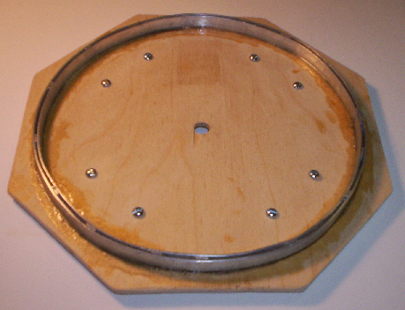  FIGURE 4.1 | 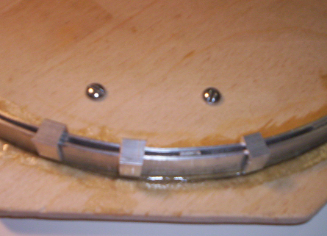  FIGURE 4.2

Construction of test materials has also been started—casks in particular. The completion of test casks will be necessary to ensure proper lift design and performance. Dimensions for a cask can be found in APPENDIX B as FIGURE 8.4. FIGURE 4.3 shows pieces of foam board, measured and waiting for holes for cans to be cut. FIGURE 4.4 shows an unfinished test cask needing to be glued and cleaned up.
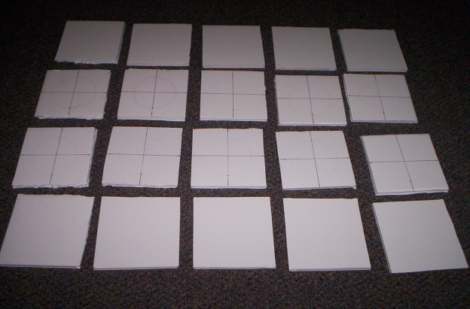  FIGURE 4.3 | 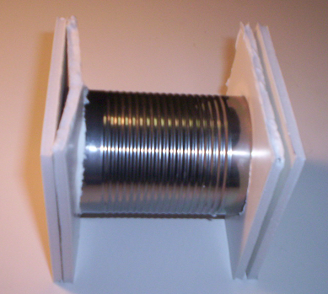  FIGURE 4.2

V. Future Work
There is still quite a bit of work to be performed in the future. There is a lot of PSoC design to implement as well as the XBC high level control. Luckily we have a lot of basic code design available from last year that will only need some tweaking before it can be used for our design. The next step in our design process is to implement the PSoC into the robot for some simple wheel control. We hope to have a robot that can perform basic tasks such as move forward, backward, or side to side with a specified velocity or distance. In doing this we can test how well our optical encoders are working and if the differential control is adjusting the wheels to move at the required velocity.
After this, we will need to install light sensor arrays and get that working to allow further testing of the differential control loops implemented in the PSoC. The PSoC will get input directly from the light sensors and make adjustments necessary to keep in a straight line. The sensor arrays are needed to ensure more accuracy. Each pair of sensors will cause a different level of adjustment to keep the robot on the line. The end result should be a robot that smoothly transitions until it finally rides a straight line. It is undesirable to have a robot that will constantly angle back and forth as it is following the line.
Once we have all of the low level controls working we can start to implement high level controls to instruct the robot to move around the board. The XBC will send a command to the PSoC to move in a direction along with where to stop. The PSoC will cause the wheels to move and stop as the light sensors report back the expected condition. All of the sensory as well as the XBC, PSoC, camera, and LCD display will need to be mounted to the frame in the most logical fashion.
VI. Summary and Conclusion
This project has been and will surely continue to be an enormous undertaking, but it is one well worth doing. The use of robotics to free humans from dangerous situations will only increase as technology moves forward. To solve our distinct problem of a robot to handle casks containing hazardous materials in a warehouse setting, we have decided to create an omnidirectionable robot which can easily move in the four primary directions of north, south, east, and west without having to rotate or turn around. The basics chassis of this robot can be used in many other applications because of its versatility and strength. To pick up casks, a fork lift will be mounted to a platform which will be able to independently rotate from one side of the robot to other, saving time and effort during the competition. This design could also be used in other applications such as a claw to grab canisters, a hose to extinguish fires, or probes collecting samples on a distant planet.
This project will also require us to design a power regulation circuit to control the multiple processing units. All of the lower level commands will be implemented with a PSoC which has unlimited applications in the world. Knowledge of accurate use of the PSoC is also sure to benefit us in future endeavors. Finally, our partnership with the computer science students to create this robot is good experience for the multidisciplinary teams we may be a part of in future jobs.
While some aspects of this robot such as the mechanical body have been coming along much faster than anticipated, other parts such as the PSoC controller, although currently on schedule, are likely to take longer than we expected. Our advisors, Dr. Engel and Dr. Weinberg, are very impressed with the work we have completed to this point and have been a huge help in clearing up the problems we have faced; however, the completion of this project is reliant on the continued work of all involved parties and the support and counseling of fellow students and advisors.
VII. Appendix A
Preliminary Schedule
Task Name | Start | Finish | Duration
1: Lift | 8/28/07 | 11/10/07 | 73 days
1.1: Design Mechanics | 8/28/07 | 9/27/07 | 30 days
1.1.1: Fork Type | 8/28/07 | 9/27/07 | 30 days
1.1.2: Tilt/Lift | 8/28/07 | 9/27/07 | 30 days
1.2: Strain Gauges | 9/27/07 | 10/11/07 | 14 days
1.2.1: Gauge Type | 9/27/07 | 10/4/07 | 7 days
1.2.2: Driver Circuit | 10/4/07 | 10/11/07 | 7 days
1.3: Acquire Materials | 9/27/07 | 10/30/07 | 33 days
1.4: Create and Test | 10/4/07 | 11/10/07 | 37 days
2: Drive Train | 9/27/07 | 11/10/07 | 44 days
2.1: Design Mechanics | 9/27/07 | 10/16/07 | 19 days
2.1.1: Steering Type | 9/27/07 | 10/4/07 | 7 days
2.1.2: Wheel Placement | 10/4/07 | 10/9/07 | 5 days
2.1.3: Chassis | 10/9/07 | 10/16/07 | 7 days
2.2: Acquire Materials | 10/9/07 | 10/30/07 | 21 days
2.3: Create and Test | 10/9/07 | 11/10/07 | 31 days
3: Power Systems | 9/27/07 | 10/30/07 | 33 days
3.1: Decide Power Type | 9/27/07 | 10/4/07 | 7 days
3.2: Regulation Circuit | 10/4/07 | 10/30/07 | 26 days
3.2.1: Design | 10/4/07 | 10/16/07 | 12 days
3.2.2: Create and Test | 10/16/07 | 10/30/07 | 14 days
3.3: Motion Test Controller | 9/27/07 | 10/18/07 | 21 days
3.3.1: Design | 9/27/07 | 10/4/07 | 7 days
3.3.2: Create and Test | 10/4/07 | 10/18/07 | 14 days
4: Integrate Systems | 11/10/07 | 12/6/07 | 26 days
4.1: Fit Together | 11/10/07 | 11/27/07 | 16 days
4.2: Test | 11/27/07 | 12/6/07 | 9 days
5: Logic | 8/28/07 | 12/6/07 | 99 days
5.1: Needs Assessment | 8/28/07
5.1.1: Maneuverability | 8/28/07
5.1.2: Tasks | 8/28/07
5.1.3: Sensors | 9/20/07
5.2: Write Basic Code
5.3: Test Control Over Body
5.4: Integrate With Body

TABLE 7.1

Revised Schedule
Task Name | Start |  | Finish | Duration | AUG |  | SEP | OCT | NOV | DEC
1: Drive Train | 9/18 |  | 11/10 | 53 days
1.1: Design Mechanics | 9/18 |  | 10/9 | 21 days
1.1.1: Wheel Arrangement | 9/18 |  | 9/25 | 7 days
1.1.2: Chassis | 9/25 |  | 10/9 | 14 days
1.2: Acquire Materials | 9/27 |  | 10/18 | 21 days
1.3: Create and Test | 10/9 |  | 11/10 | 32 days
2: PSoC Programming | 9/27 |  | 11/10 | 74 days
2.1: Strain Gauges | 9/27 |  | 10/30 | 33 days
2.1.1: Prototype Testing | 9/27 |  | 10/30 | 23 days
2.1.2: Grams Conversion | 10/10 |  | 10/30 | 20 days
2.2: PID Loop | 9/27 |  | 10/31 | 34 days
2.2.1: Study Old Code | 9/27 |  | 10/31 | 34 days
2.2.2: PID Coefficients | 10/10 |  | 10/31 | 21 days
2.2.3: Double for Wheels | 10/31 |  | 11/10 | 10 days
3: Robot Body | 10/9 |  | 11/20 | 42 days
3.1: Turnstile | 10/9 |  | 10/31 | 22 days
3.1.1: Platform | 10/9 |  | 10/14 | 5 days
3.1.2: Track | 10/12 |  | 10/16 | 4 days
3.1.3: Motor Placement | 10/16 |  | 10/31 | 15 days
3.2: Lift | 10/3 |  | 11/10 | 11 days
3.2.1: Design | 10/30 |  | 11/2 | 3 days
3.3.3: Create and Test | 11/2 |  | 11/10 | 8 days
3.3: Upper Level | 10/31 |  | 11/20 | 20 days
3.3.1: Platform | 10/31 |  | 11/7 | 7 days
3.3.2: Electronics Mounting | 11/7 |  | 11/20 | 13 days
3.3.3: Sensory Mounting | 11/7 |  | 11/20 | 13 days
4: Electronics | 10/31 |  | 11/30 | 30 days
4.1: Power Regulation | 10/31 |  | 11/7 | 7 days
4.1.1: Design | 10/31 |  | 11/4 | 4 days
4.1.2: Create and Test | 11/4 |  | 11/7 | 3 days
4.2: Sensory | 10/31 |  | 11/30 | 30 days
4: Integrate Systems | 11/10 |  | 12/6 | 26 days
4.1: Fit Together | 11/10 |  | 11/27 | 16 days
4.2: Test | 11/27 |  | 12/6 | 9 days
5: Logic | 8/28 |  | 12/6 | 100 days
5.1: Needs Assessment | 8/28 |  | 10/1 | 64 days
5.1.1: Tasks | 8/28 |  | 9/5 | 7 days
5.1.2: Strategy | 9/5 |  | 11/1 | 57 days
5.2: Write Basic Code | 11/1 |  | 12/6 | 35 days
Caleb: |  | Kurt: |  |  |  | Both:

TABLE 7.2
Schedule Showing Planned versus Actual Work

 | Planned |  |  | Actual
Task Name | Start | Finish | Duration | Status | Relevance
1: Drive Train | 9/18 | 11/10 | 53 days | Completed 10/5 | Ahead
2: PSoC Programming | 9/27 | 11/10 | 74 days | Current | On Time
2.1: Strain Gauges | 9/27 | 10/30 | 33 days | Current | On Time
2.1.1: Prototype Testing | 9/27 | 10/30 | 23 days | Current | On Time
2.1.2: Grams Conversion | 10/10 | 10/30 | 20 days | Future | On Time
2.2: PID Loop | 9/27 | 10/31 | 34 days | Current | On Time
2.2.1: Study Old Code | 9/27 | 10/31 | 34 days | Current | On Time
2.2.2: PID Coefficients | 10/10 | 10/31 | 21 days | Current | On Time
2.2.3: Double for Wheels | 10/31 | 11/10 | 10 days | Future | On Time
3: Robot Body | 10/9 | 11/20 | 42 days | Current | On Time
3.1: Turnstile | 10/9 | 10/31 | 22 days | Current | On Time
3.1.1: Platform | 10/9 | 10/14 | 5 days | Completed 10/14 | On Time
3.1.2: Track | 10/12 | 10/16 | 4 days | Completed 10/15 | On Time
3.1.3: Motor Placement | 10/16 | 10/31 | 15 days | Current | On Time
3.2: Lift | 10/3 | 11/10 | 11 days | Future | On Time
3.2.1: Design | 10/30 | 11/2 | 3 days | Current | Ahead
3.3.3: Create and Test | 11/2 | 11/10 | 8 days | Future | On Time
3.3: Upper Level | 10/31 | 11/20 | 20 days | Future | On Time
3.3.1: Platform | 10/31 | 11/7 | 7 days | Future | On Time
3.3.2: Electronics Mounting | 11/7 | 11/20 | 13 days | Future | On Time
3.3.3: Sensory Mounting | 11/7 | 11/20 | 13 days | Future | On Time
4: Electronics | 10/31 | 11/30 | 30 days | Current | Ahead
4.1: Power Regulation | 10/31 | 11/7 | 7 days | Future | On Time
4.1.1: Design | 10/31 | 11/4 | 4 days | Current | Ahead
4.1.2: Create and Test | 11/4 | 11/7 | 3 days | Future | On Time
4.2: Sensory | 10/31 | 11/30 | 30 days | Current | Ahead
4: Integrate Systems | 11/10 | 12/6 | 26 days | Current | Ahead
4.1: Fit Together | 11/10 | 11/27 | 16 days | Current | Ahead
4.2: Test | 11/27 | 12/6 | 9 days | Future | On Time
5: Logic | 8/28 | 12/6 | 100 days | Current | On Time
5.1: Needs Assessment | 8/28 | 11/1 | 64 days | Current | On Time
5.1.1: Tasks | 8/28 | 9/20 | 23 days | Completed 9/20 | On Time
5.1.2: Strategy | 9/5 | 11/1 | 57 days | Current | On Time
5.2: Write Basic Code | 11/1 | 12/6 | 35 days | Future | On Time

TABLE 7.3

VIII. APPENDIX B

Overall Design Block Diagram

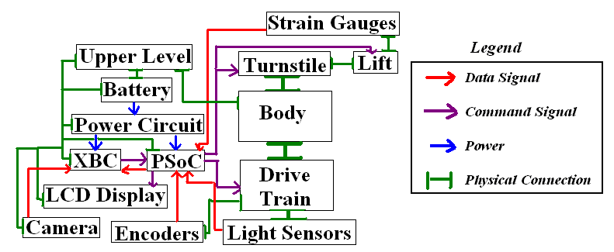FIGURE 8.1

Chassis Frame Design

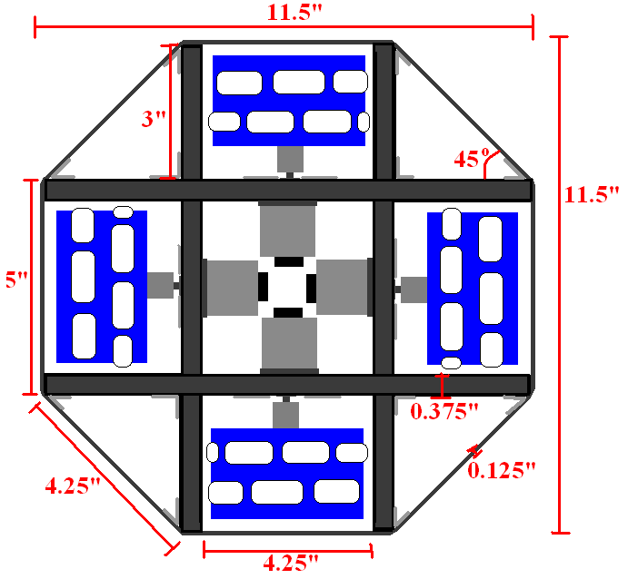
FIGURE 8.2

Turnstile Concept

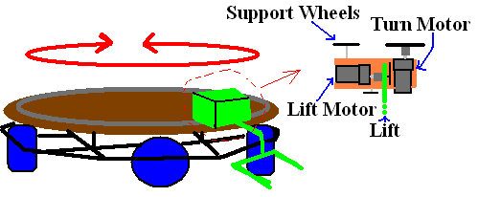
FIGURE 8.3

Cask Dimensions
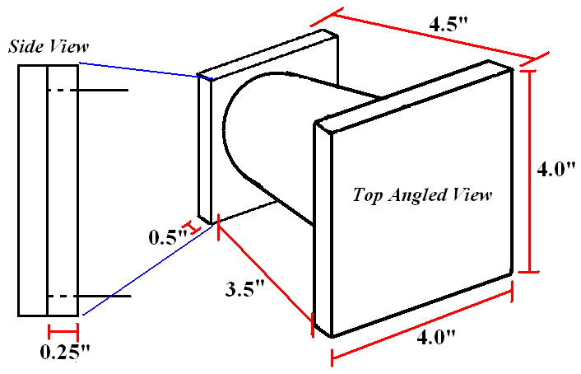
FIGURE 8.4

